Current Market View – March 2026

Investment Markets
Global Markets
Global markets delivered their weakest month in years in March 2026 as the U.S.–Iran conflict triggered a broad risk-off shock across equities, bonds, and commodities. Major indices fell sharply: the S&P 500 dropped 5%, its worst month since 2022, while the MSCI World Index slid 6.4% as losses deepened across Europe and Asia. Emerging markets were hit hardest, falling around 13%, with Korea and South Africa leading declines as investors priced in weaker global growth and heightened geopolitical uncertainty. Bonds offered little protection, with global government and corporate debt selling off as surging oil prices pushed inflation expectations higher and forced markets to reassess the path of interest rates.
Commodities were the lone bright spot, with energy prices soaring after the effective closure of the Strait of Hormuz disrupted global supply. Brent crude rose more than 60% to more than US$100 per barrel for the first time since 2022, driving the energy sector to gains of more than 10% while nearly every other sector posted declines of 3% or more. The U.S. dollar strengthened on safe-haven flows, while gold fell amid rising yields that weighed on non-yielding assets.

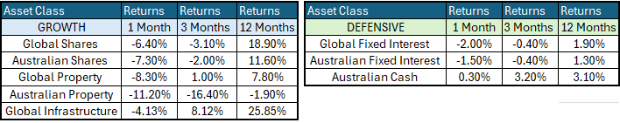

Global Share Markets
Global share markets saw a broad-based equity selloff, with nowhere to hide. All sectors finished the month in the negative, except Energy and Utilities. Oil saw a very positive month, boosted by the war in Iran, with oil prices rising 43% and LNG prices rising 88%. On the flip side, precious metals were weaker during the month, with silver down -20% and gold down -11%, as investors moved back to the US Dollar.
Technology had a weak month, with the software business continuing to be weaker amid AI fears that the barriers to entry for software companies could be shrinking. Also being hit by AI bubble fears were several U.S. financial stocks, with rising concerns over exposures to private credit lending to AI firms and data centres, both directly and indirectly via hedge funds, venture capital, and retail private credit funds. This space is riddled with related-party transactions, concocted accounts, and fudged valuations, so nobody actually knows where potential losses are.
March saw developed markets underperform the United States, with Asian economies falling the most due to their heightened reliance on Middle Eastern oil. Within European equities, Germany and France were the lowest performers amid fears of slowing growth and the possibility of higher interest rates this year.
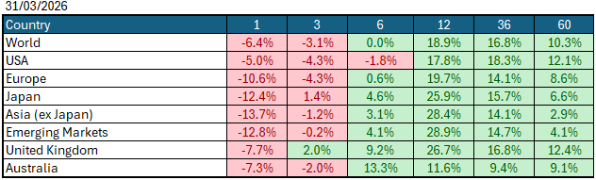
Data Source: AFM as of March 31, 2026.

Global Bond Markets
Bond markets posted losses as yields worldwide rose following the war in Iran, triggering the potential for a world of higher, stickier inflation and higher global interest rates. Bond investors are now starting to price in elevated interest rates globally, as governments may come under pressure to run fiscal deficits amid a global slowdown. Over the month, credit spreads widened from very tight levels as investors sought to move assets into more "safe harbour" assets.
Interest rate markets in the U.S. and the UK rose in March 2026, with the 10-year Government bond rate rising to 4.311%. UK 10-year Gilts were trading at 4.895% on March 31 2026.
Domestic Bond Markets
Treasury yields rose across all maturities in Australia as markets continue to price in rate hikes and stickier inflation. For Australia, the latest inflation prints for (year-on-year) February 2026 declined marginally to 3.7%, down from 3.8% in January. The RBA board is set to meet on the 4th/5th May 2026, with market pricing giving a 50:50 chance of a +25bps rate hike to 4.35%.

Investment Climate
U.S. equities ended March 2026 on a weaker note, driven by geopolitical events in the Middle East that caused a surge in oil prices. Currently, the looming threat of a global inflation spike could force many economies to raise interest rates. Given the current tensions in the Middle East, we could potentially see a global slowdown in GDP, as energy production cannot keep up with the rollout of AI data centres. Share markets fell across the board, with only energy and insurance companies seeing improved share prices since the war broke out. There has been a rotation out of growth companies into hard asset companies with higher free cash flow and more certain revenues.
Over the medium term, investors are encouraged by the anticipated productivity benefits from AI and the hyperscalers' investments in AI. However, with the unsettled nature of the share and bond markets due to the war in Iran, the short term has put the handbrake on the level of encouragement. If the US changes its tone and begins raising interest rates under its new Federal Chairman, Kevin Warsh, the medium term could become much less encouraging.
Long-term investors are cautiously optimistic about a recovery period ahead. Global central banks continue to indicate a resolve to get inflation under control; however, economic data is showing signs of stabilisation despite elevated inflation, which could lead central banks to increase interest rates in 2026.
The following commentary is based on month-end closing prices as of March 31, 2026:
Global share markets were all weaker in March, driven by geopolitical events in the Middle East, with Japan, China and South Korea underperforming the U.S. and European markets due to their higher reliance on Middle Eastern oil. The AUD/USD weakened from 0.7116 to 0.6900 (-3%).
The U.S. Fed held the federal funds rate target range at 3.50%-3.75% when it met on the 17th/18th March 2026. Last month, the rhetoric of a soft landing came under pressure amid the expected increase in inflation following the oil price spike, which has brought the chances of a rate hike in the US back to the table. The next Fed meeting is on the 28th/29th April 2026.
The underlying short-term theme is "cautious" for shares.
The situation in the Russia/Ukraine conflict remains unchanged, with the latest conflict between Israel and Gaza (Hamas) remaining unchanged as well. Volatility and risk increased as the USA/Israel moved towards a war with Iran.
Investor Focus
For Australia, investors focused on the following issues:
- Cost of living expenses and the impact on consumer spending.
- Commodity prices (post-China policy changes) and the impact on company profits.
- The level of interest rates and the delicate position of the RBA, given the global volatility in markets.
- Rising Oil Prices as conflicts with Iran escalated
- U.S. tariffs and the impact on Australia's exports (if any).
- Inflation (year-over-year) remained flat at 3.8% in December, with the next quarterly CPI being released on April 29, 2026.
- Government spending and the rising debt level.

Currency
The Australian Dollar closed stronger, AUD/USD 0.69 at the end of March 2026, down from 0.71. As the Aussie dollar is a 'risk currency', it always sells off in a global crisis, regardless of local conditions. In March, it fell against all major currencies, especially the US dollar. Conversely, the US is the global 'safe haven' currency (and has been since WW1), and so it (almost) always rises in global crises, even if the US is the cause of the panic (for example, in the GFC). As global investors (i.e., primarily US investors) panicked-sold just about everything in March and retreated home, the US dollar strengthened against all other major currencies.

Currency forecasters see the AUD/USD range between:
0.65 and 0.75 cents in the medium term and most likely to trade within the:
0.5500 to 0.7500 range in the longer term.

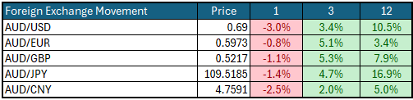

Australian Economy
Australia's latest GDP data for the final quarter of 2025 showed an annual growth rate of 2.6%, up from 2.1% in the third quarter of 2025. Unemployment fell marginally in February to 4.2%, down from 4.3% in January 2026. The year-over-year (Y-O-Y) inflation rate also remained very sticky at 3.7% in February 2026, and remains outside the Reserve Bank's targeted 2% to 3% inflation range and could lead to a second rate hike in May.

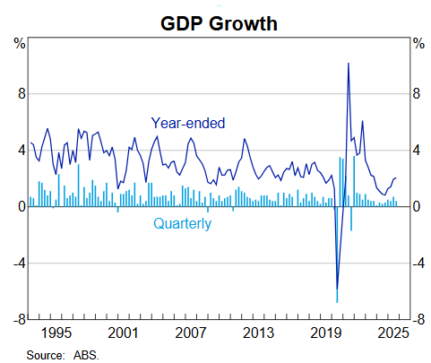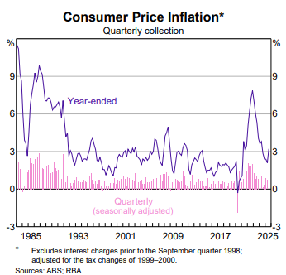

Current Market View

Domestic View
The overall investment view for shares is "cautious" over the short term, "cautiously optimistic" over the medium term, and "long run" as corporate profits continue to grow faster than inflation and the need to build out data centres to drive commodity prices.
The market is currently 50:50 on an interest rate hike on the 4th/5th of May 2026, due to a "hotter" inflation print in February that showed inflation is now outside the RBA's target range of 2-3%, in combination with increases in the oil price to increase inflation over the short-term.

Global View
The global share market remains cautious, with the looming threat of an inflation spike globally that could see many economies have to increase interest rates. Given the current tensions in the middle east, globally we could potentially see a slowdown in GDP as energy production cannot keep up with the rollout of AI datacentres.

Where to From Here?
- Continued shift from rules-based order and win-win multi-lateral trade to power-based order and win-lose trade deals. Trump did not start this. The shift started in the 2010s with the U.S./Europe letting Putin take Crimea in return for cheap gas for Germany/Europe, and the U.S./Japan letting China militarise the South China Sea. It has certainly accelerated under Trump. Lower cross-border trade & investment, more reliance on government subsidies & distortions, and inflationary onshoring of uneconomic industries.
- Sticky inflation - political pressure on central banks to keep rates low – populist pressure on governments to keep deficit spending. Tariffs + onshoring adding to costs/prices. Bond yields to stay elevated or even drift higher, risk of bond yield spikes, or a sudden need for rate hikes, unsettling / breaking share markets.
- Share markets continue to be supported by good profit growth for now. Shares everywhere are expensive, but buoyed by loose monetary & fiscal policies, plus a near-certainty that governments will throw 'free'/borrowed money at any problem.
- Commodities rally gathering pace – rising demand soaking up oversupply, AI/data centre boom (industrial metals, energy, water, land), global rearmament – especially Europe, Japan, Canada. This should support the ASX market, as long as banks avoid a local recession.
- De-dollarisation fears are probably overdone, but are driving up gold and silver, not bitcoin. U.S. Treasury yields are not at risk for now (and even fell in February).
- The current boom will end one day, of course. All markets everywhere, including and especially Australia, are over-priced on fundamentals, not just U.S. big tech. However, each boom is different, and the triggers for the inevitable bust are different each time.

This document is issued by Atlas Funds Management Pty Ltd. Atlas Funds Management Pty Ltd does not provide any general advice or personal advice regarding any potential investment in any financial products within the meaning of section 766B of the Corporations Act. No consideration has been made of any specific person's investment objectives, financial situation or needs. The provision of this presentation is not and should not be considered as a recommendation in relation to an investment in any entity or that an investment in any entity is a suitable investment for any specific person. Recipients should make their own enquiries and evaluations they consider appropriate to determine the suitability of any investment (including their investment objectives, financial situation, and particular needs) and should seek all necessary financial, legal, tax and investment advice. Atlas Funds Management Pty Ltd, it's directors and employees do not accept any liability for the results of any actions taken or not taken on the basis of information in this presentation, or for any negligent misstatements, errors or omissions. This presentation is not an advertisement and is not intended for public use or distribution. Past performance of a fund is no guarantee of its future performance.

